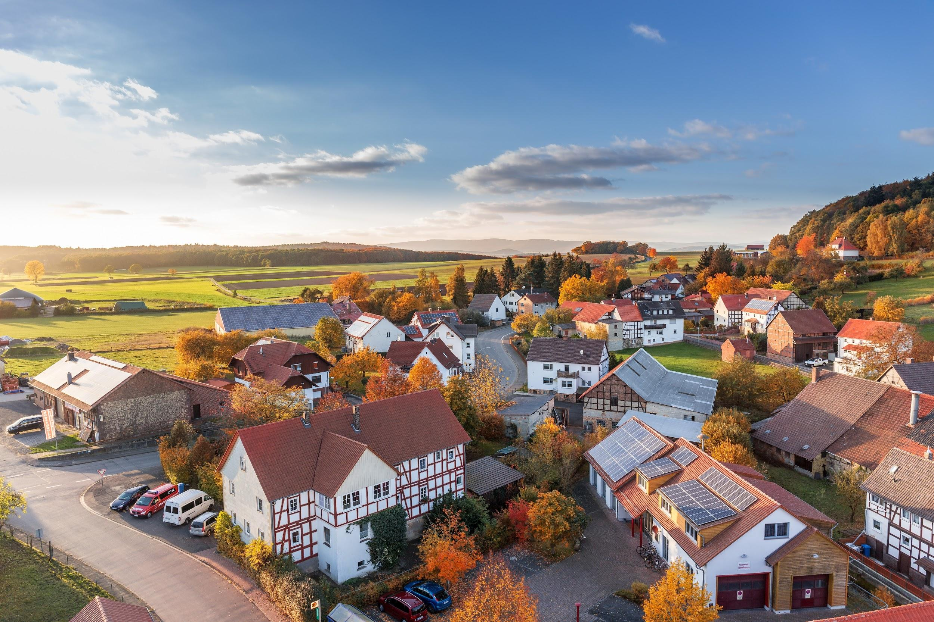
Image Source - Pexels

Making money through real estate in this economy

With so many unreliable and potentially dangerous investment opportunities in existence in today's modern world, it’s fair to say that it’s tough to break through the junk to find the most profitable ideas. Fortunately, one option that has continually proven itself to be a profitable and rewarding investment opportunity is real estate.

Real estate has been providing smart investors with a healthy income for many years, and the 21st century is no exception! You can expect to generate a very respectable profit margin when you make smart investments in property, but how do you make money through real estate in this economy?

Making Money Through Real Estate In This Economy
Today's economy certainly isn’t in the best of shapes. There are different issues and dangers that you need to contend with, from high inflation on the rise, to a cost of living crisis, potential recession and constantly increasing interest rates that are leaving everyone but the top 1% out in the cold.

However, despite these many challenges, there are just as many solutions that can be implemented to ensure that everyone, no matter what their financial background, can start to generate a healthy income through real estate investment.

It’s fair to say that there are a number of different influencing factors that can impact on your ability to make money from property, with a few being totally out of your control.

However, most of these factors are controllable, meaning you can certainly steer your investment ship in the direction of success to improve your chances of making a huge profit from your chosen property!

What To Look Out For To Start Making Money & Building Wealth Through Real Estate
Looking out for a few key features can help you to stand the best chance of making money through real estate, no matter what your past experience level may be. Here are a few brilliant examples:

Finding The Perfect Balance Of Demand And Supply
In particularly busy locations such as capital cities or even in family neighborhoods surrounding schools, you’ll no doubt find that demand outweighs supply. In simple terms, this just means that there are far more people looking to buy or rent a property than there are properties available. If there aren’t enough houses for those who want to live there, then property investors are the ones who hold all of the power.

In places where demand outweighs supply, the price of real estate rises far faster than other areas, and can subsequently provide you with a faster, larger profit. Being able to identify such locations that will continue to grow in population despite having a limited number of properties will certainly put you on the right track to real estate superstardom.

Choosing Between A Buy To Sell, And A Buy To Let or Lease
Although in some cases it will make far better sense for you to resell real estate, there are also many situations in which it can become much more profitable for you to rent rather than selling. Being able to purchase a valuable property such as a HMO (house of multiple occupation) could be the perfect opportunity for you, as you can continually charge a monthly lease fee from each and every tenant that you have inside your property.

This means that you could do something like convert a large family home into separate accommodation, converting one potential payment into 3 or 4 streams of income. Renting can be a very profitable business to explore, but just remember that it will take more time and energy than simply buying to resell.

Learning How To Thrive Through Calculated Risks
Due to the steady downfall of the global economy in the last 3-5 years, many investors are turning their noses up at potentially risky opportunities out of fear or anxiety. Although it is generally smart to avoid dangerous financial situations, it’s important to recognize that it’s not always the case.

In fact, taking calculated risks often does pay off well in the world of real estate, and such a decision could be the starting point of your career that catapults you in the direction of success. The key here is the word ‘calculated’, as you need to make sure the risks do not outweigh the potential benefits.

Making money through real estate in today's economy doesn’t have to be as difficult as you might initially expect. If you’d like to learn more about how you can start to build your wealth by investing in real estate, then there’s no time like the present to sign up for RPI Education’s expert training sessions, find out more about our events, and check out our handy website!

